MTW Series European Technology Trapezium Mill

Brief introduction:
MTW SERIES EUROPEAN TECHNOLOGY TRAPEZIUM MILL--the latest grinding equipment, with its own knowledge patents, have reached modern advanced level in the world. This series mill absorbing the European advanced technology and many engineers’ ripe experience, combining the actual requirement and proposal of our 9518 customers’, have been developed on the basis of our professional engineers’ hard researching. This new type mill adopts bevel gear overall drive, inner automatic Thin-Oil lubricating system, arc air channel and several latest patent technology.
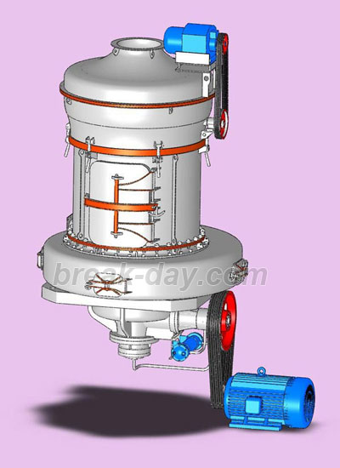

The new technology as below;
1) Bevel gear overall drive: the traditional grinding mill is driven by speed reducer and coupling. It is hard to be installed. And there will be too much noisy, and the efficiency is lower. MTW series mill is driven by bevel gear, so its structure is compacter, easy to be installed and more efficient.
2) Inner automatic Thin-Oil lubricating system: the traditional mill adopts grease lubrication, so the lubricating resistance is stronger, the temperature will be higher soon, the bearing life is shorter. MTW series mill adopts inner L.O. pumps, so the main shaft bearing and bevel gear can be lubricated without an additional lubrication system.
3) Arc air channel: all of the air channel of traditional grinding mill is upright board type. In this case, there will be stronger resistance when the air impacts the air channel board, and the energy of collisions of air molecules loss heavily, as a result, the air channel will be jammed easily because of the eddy air flow. MTW series mill adopts a cambered air channel, the tangential air goes into air channel easily because there is small resistance. And the inner outlet is very good for the grinded material to spread around and avoid grinding material jammed.
4) Cambered shovel with renewable edge: The traditional shove is integral and edge always be worn out quickly, so you have to renew it in short time which affects the working time and wastes too much steel. The shovel edge of MTW series mill adopts high wearable limit alloy, its life will be longer. You only want to change the edge, not the whole shovel. so the steel material is saved. In addition, because the traditional shovel is plane type, the grinded material stacks on the same plane when it is scooped up. So the middle parts of the roller is worn out heavily. But the cambered shovel can scoop up the grinded material in the same vertical plane, that makes the rollers and ring worn equally. At the same, the grinding efficiency is higher and capacity is higher;
5) Separated cyclone: There is a separated structure between inner piping and mixed air and powder. The efficiency and precision of classifying is promoted highly;
6) No resistance snail shell (small checking door so that there is not an eddy air flow): In the traditional grinding mill, the checking door of snail shell is prominent, that mean the checking door and snail shell are not on the same plane. So there will be eddy air flow easily come into being. As a result, the energy waste is bigger. MTW series mill make the inner surface of checking door stay with the inner surface of snail shell on the same plane, so the eddy air flow is avoided efficiently;
7) Perfect outward appearance: Both of the inner parts and outer part of the MTW series mill adopt advanced structure and beautiful arc structure design. This makes the mill advanced and beautiful.

Usage:
This equipment is mainly used to grind minerals in the field of metallurgy, construction, chemical industry, mining, etc., including lime stone, quartz, feldspar, calcite, talcum, barite, fluorite, thulium，marble, porcelain, bauxite, manganese, iron ore, copper ore, phosphorite, ferric oxide(red), zirconium, slag, active carbon, dolomite, granite, ferric oxide(yellow), bean cake, fertilizer, compound fertilizer, coal ash, soft coal, lignite, magnesite, chrome oxide, gold mine, red mud, clay, kaolin, coke, china clay, kyanite, fluorite, rhyolite, greenstone, shale, basalt, gypsum, graphite, carborundum, heat-retentive materials which are non-flammable, non-explosive, with Moh’s hardness below 9 and moisture below 6%.

Main Technical Data:
Model Specification Name | MTW110 | MTW138 | MTW175
Quantity of roller (PCS) | 4 | 4 | 6
Inner diameter of ring (mm) | Ф1100 | Ф1380 | Ф1750
Rotary speed of main frame(r/min) | 120 | 96 | 75
Max. Feeding size(mm) | < 30 | < 35 | < 40
Output size (mm) | 1.6～0.045 The fineness is 0.038 | 1.6～0.045 The fineness is 0.038 | 1.6～0.045 The fineness is 0.038
capacity (t/h) | 3.5～10 | 6.5～15 | 11～25
Overall dimension (mm) | 8910×6950×9010 | 9860×8340×10227 | 13500×11500×9500
Total weight (t) | 18 | 28.5 | 46
Remarks: Capacity is based on grinding limestone, 80% passing-through. If the technical data and overall dimension is changed, it is subjected to the operation manual which is together with delivered goods.

Contact Us:
Address: No. 15, Dingxiangli Road, National HI-TECH Industry Development Zone, Zhengzhou, China.
Postcode: 450001
Tel: 0086-371-67992899 67371699 67999318 67996989
Fax: 0086-371-67992699
Email: Break-day@break-day.com
MSN Online: MiningMachine@hotmail.com
MSG Online: Summer_8001@yahoo.com
Skype: miningmachinery

